EXPT NO: 7 | GENERATE SYNTHETIC IMAGES USING A GENERATIVE ADVERSARIAL NETWORK (GAN)
DATE: 09/10/2026

PRE-LAB QUESTIONS (PROVIDE BRIEF ANSWERS TO THE FOLLOWING QUESTIONS)

- What is a Generative Adversarial Network (GAN)?

A Generative Adversarial Network (GAN) is a deep learning architecture used to generate new and realistic data. It consists of two neural networks called the Generator and Discriminator, which are trained together in an adversarial manner.

- What are the roles of the Generator and Discriminator in a GAN?

The Generator creates synthetic data, such as images, from random noise. The Discriminator evaluates the input data and determines whether it is a real sample from the dataset or a fake sample generated by the Generator.

- Why are GANs used for synthetic image generation?

GANs can learn the important patterns, structures, and features present in real images. After training, the Generator can use this learned information to create new synthetic images that are visually similar to real images.

- What is the difference between real images and synthetic images?

Real images are obtained directly from an original dataset, camera, or other real-world source. Synthetic images are artificially generated by a machine learning or deep learning model. Synthetic images are not directly present in the original dataset.

- Explain the concept of adversarial training in GANs.

Adversarial training is the process in which the Generator and Discriminator compete with each other. The Generator tries to create images that can fool the Discriminator, while the Discriminator tries to correctly distinguish real images from generated images. Through this competition, both networks improve their performance.

AIM
To implement a Generative Adversarial Network (GAN) for generating synthetic images by training a Generator and Discriminator on an image dataset and evaluating the quality of the generated images.

SOFTWARE REQUIREMENTS
- Python
- TensorFlow / Keras
- Google Colab
- GitHub
- NumPy
- Matplotlib
- Pandas

OBJECTIVES
Students will be able to:
- Understand the architecture and working of Generative Adversarial Networks.
- Understand the roles of the Generator and Discriminator.
- Prepare and preprocess an image dataset for GAN training.
- Build a Generator network for synthetic image generation.
- Build a Discriminator network for distinguishing real and generated images.
- Train a GAN using adversarial learning.
- Generate synthetic images using the trained Generator.
- Visualize and analyze the quality of generated images.

PROCEDURE
PART A: DATASET PREPARATION AND IMAGE PREPROCESSING
Perform the following tasks:
- Load an image dataset such as the MNIST handwritten digit dataset.
- Explore the dataset and examine sample images.
- Check the number of images and image dimensions.
- Display sample images from the dataset.
- Normalize the pixel values to the range [-1, 1].
- Reshape the images into the required input format.
- Prepare the dataset for batch-wise training.
- Create a data pipeline using appropriate TensorFlow/Keras utilities.
(CODE: CONATAINS STUDENT ROLL NOS
SCREENSHOT OF CODE
SCREENSHOT OF OUTPUT)
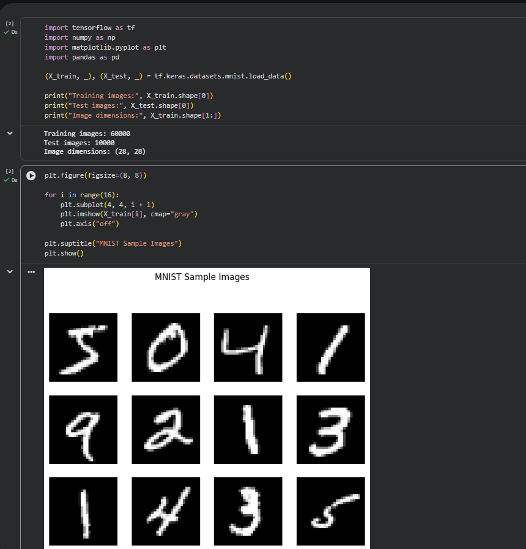

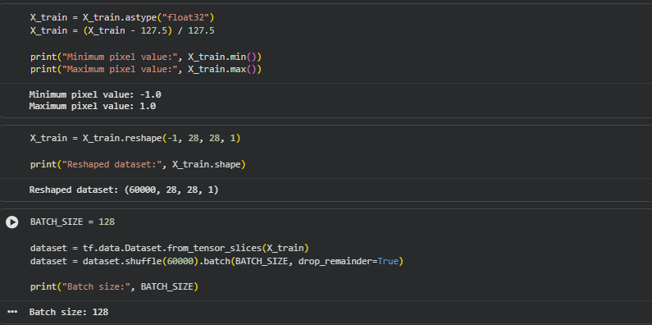

PART B: IMPLEMENTING THE GENERATOR
Perform the following tasks:
- Define a random noise vector as the input to the Generator.
- Create the Generator using appropriate neural network layers.
- Use Dense and convolutional/transposed convolutional layers to generate images.
- Apply appropriate activation functions.
- Generate an image from a random noise vector.
- Display the generated image before GAN training.
- Display the Generator model architecture and summary.
(CODE: CONATAINS STUDENT ROLL NOS
SCREENSHOT OF CODE
SCREENSHOT OF OUTPUT)

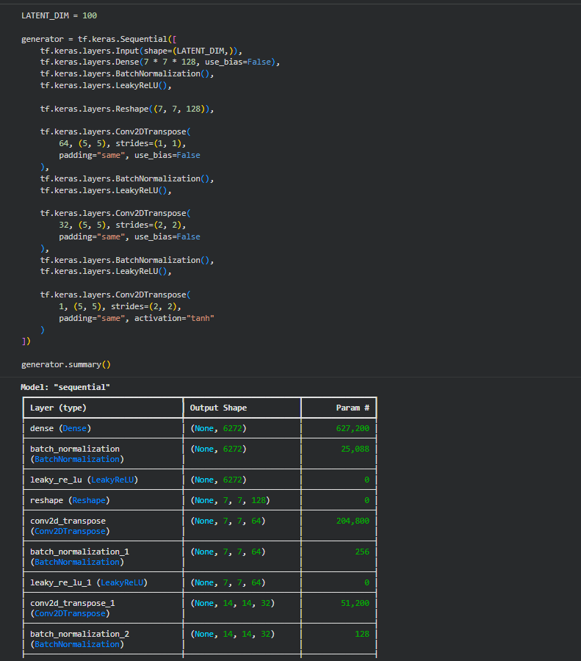

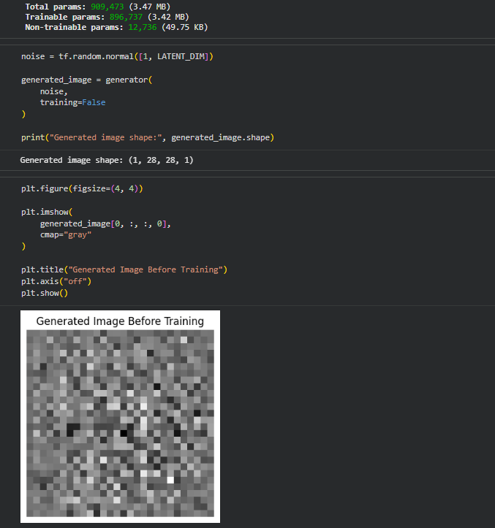

PART C: IMPLEMENTING THE DISCRIMINATOR AND GAN MODEL
Perform the following tasks:
- Create a Discriminator network to classify images as real or generated.
- Add convolutional layers to extract image features.
- Add appropriate activation functions.
- Add a final output layer for binary classification.
- Compile the Discriminator using:
  - Appropriate optimizer
  - Binary cross-entropy loss
- Combine the Generator and Discriminator to form the GAN.
- Display the Generator and Discriminator model summaries.
(CODE: CONATAINS STUDENT ROLL NOS
SCREENSHOT OF CODE
SCREENSHOT OF OUTPUT)

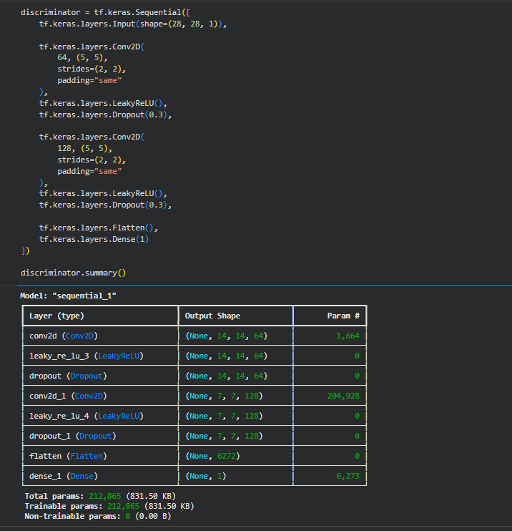

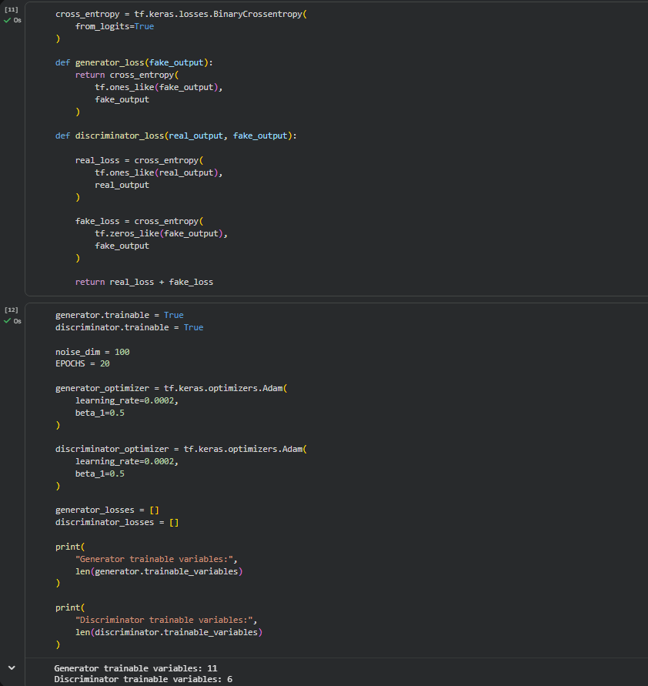
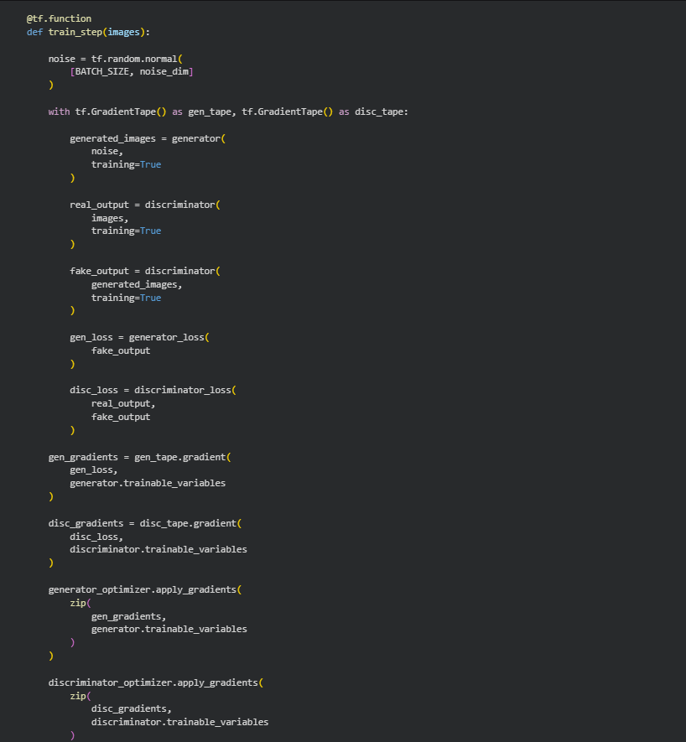

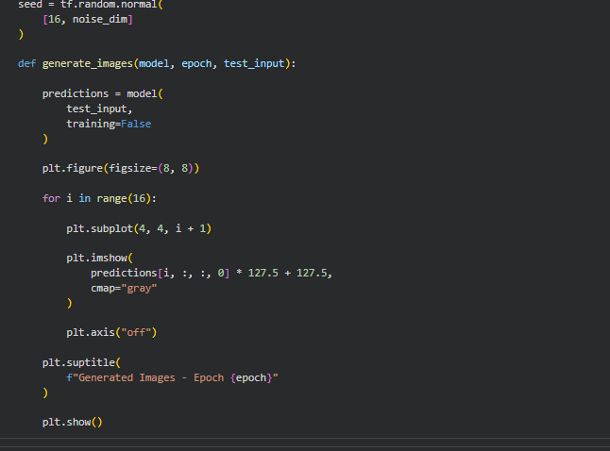

PART D: GAN TRAINING AND SYNTHETIC IMAGE GENERATION
Perform the following tasks:
- Initialize the Generator with random noise.
- Train the Discriminator using:
  - Real images from the dataset.
  - Synthetic images generated by the Generator.
- Train the Generator through the combined GAN model.
- Record:
  - Generator loss
  - Discriminator loss
- Repeat the training process for the specified number of epochs.
- Generate synthetic images at regular training intervals.
- Visualize generated images at different stages of training.
- Compare the generated images with real images.
- Analyze the quality and diversity of the generated images.
- Save the final generated images.
(CODE: CONATAINS STUDENT ROLL NOS
SCREENSHOT OF CODE
SCREENSHOT OF OUTPUT)

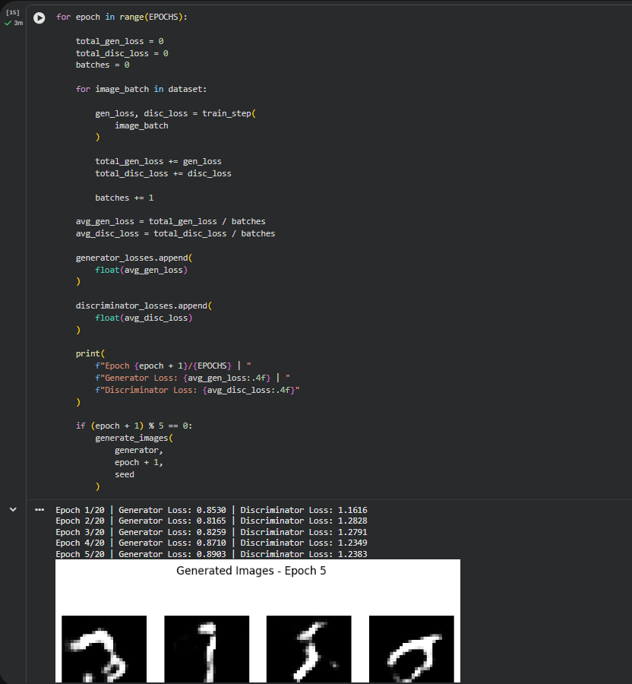
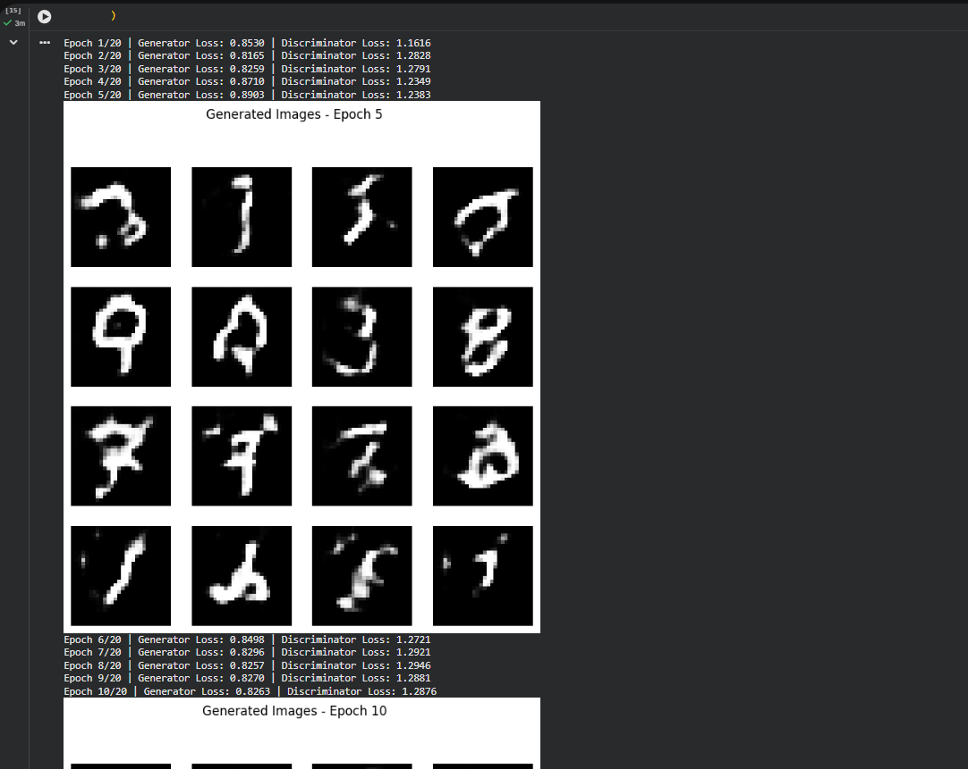

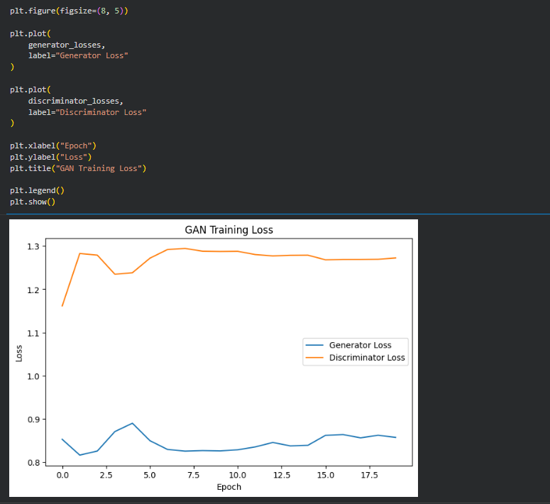

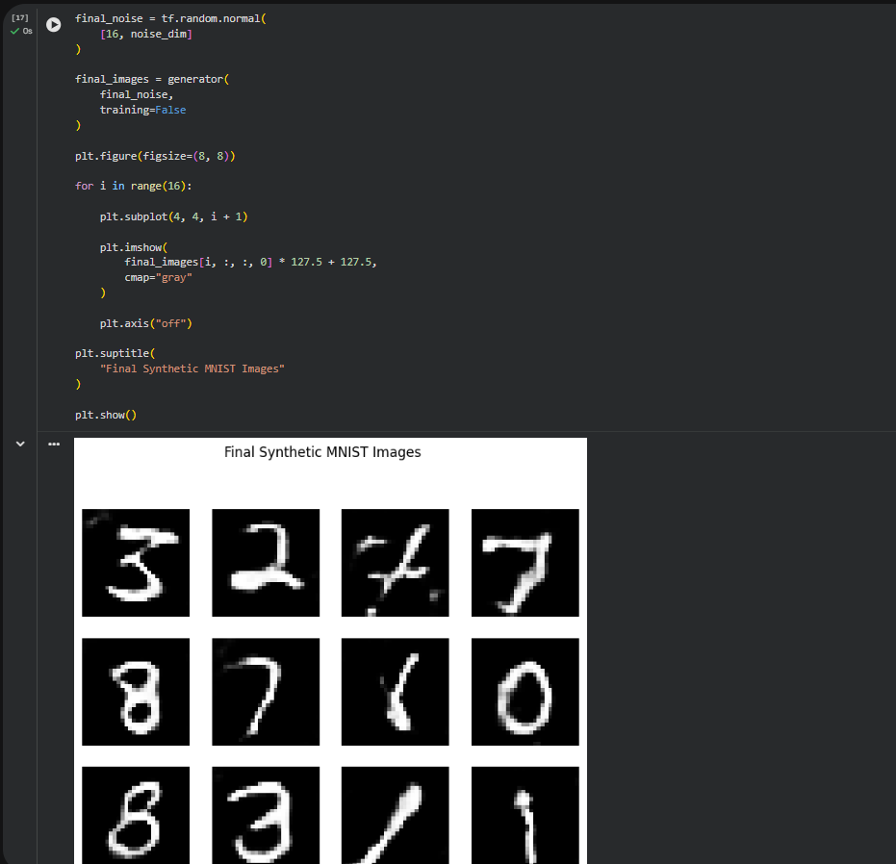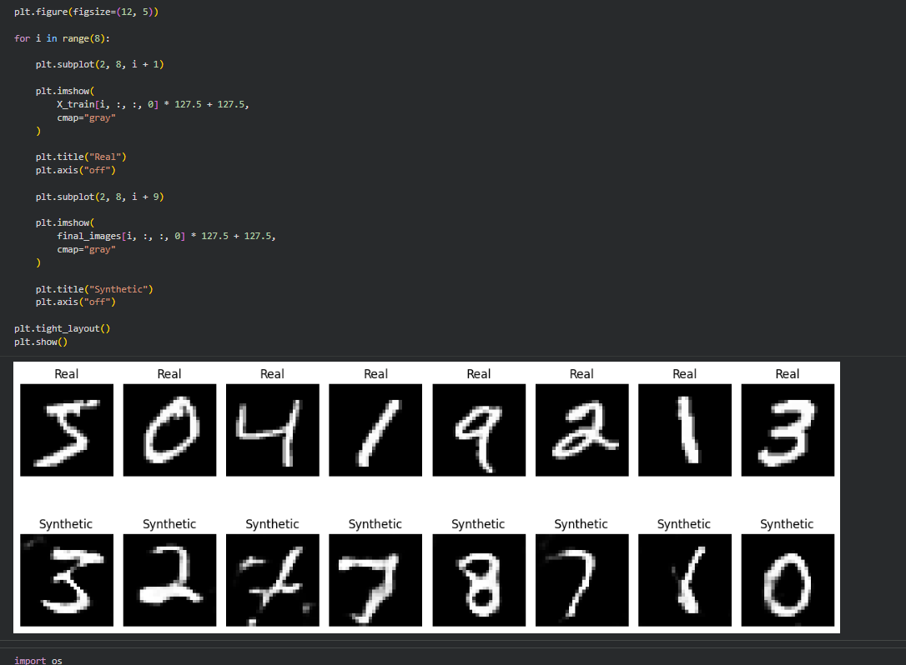

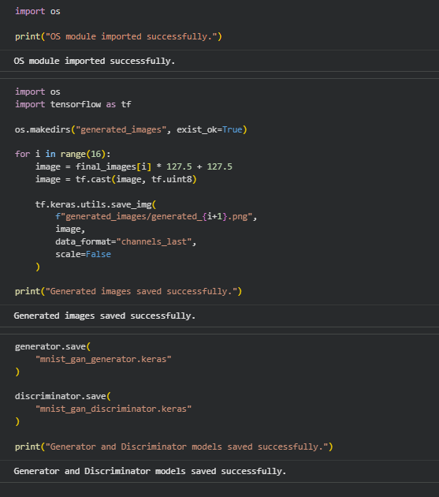

EXPECTED OUTCOME
Students will understand the architecture and working of Generative Adversarial Networks (GANs) and the interaction between the Generator and Discriminator during adversarial training. Students will learn to preprocess image data, build and train GAN models, and generate synthetic images. They will evaluate the generated images by visually comparing them with real images and analyzing the improvement in image quality during training.

POST-LAB QUESTIONS (PROVIDE BRIEF ANSWERS TO THE FOLLOWING QUESTIONS)

- What is the role of the Generator in a GAN?

The Generator is responsible for creating new synthetic images from random noise. During training, it learns the features of the real dataset and gradually improves the quality and realism of the generated images.

- What is the role of the Discriminator in a GAN?

The Discriminator acts as a binary classifier. It receives both real and generated images and predicts whether each image is real or fake. Its feedback helps the Generator improve its generated images.
- Why is random noise used as input to the Generator?

Random noise provides a variable input to the Generator, allowing it to produce different images. It helps the Generator learn a distribution of possible images rather than simply memorizing the training dataset.

- What happens when the Discriminator becomes too strong during GAN training?

If the Discriminator becomes too strong, it can easily distinguish real images from generated images. As a result, the Generator receives very little useful learning feedback, which can slow down or destabilize the GAN training process.

- What is meant by mode collapse in GANs?

Mode collapse is a common GAN problem where the Generator produces limited varieties of images. Instead of generating diverse samples, it may repeatedly generate very similar images even when different random noise vectors are provided.

- How does the Generator improve the quality of generated images during training?

The Generator receives feedback through the Discriminator's output. It updates its weights using backpropagation and optimization techniques so that its generated images become increasingly realistic and difficult for the Discriminator to identify as fake.

- Mention one real-world application of GANs.

One important application of GANs is synthetic image generation. They can be used to generate realistic human faces, enhance low-resolution images, create artwork, and produce additional training data for machine learning models.

- What is the difference between GAN training and conventional neural network training?

In conventional neural network training, a model generally learns from a predefined target using a single loss function. In GAN training, two networks compete with each other: the Generator tries to create realistic data, while the Discriminator tries to detect fake data. This adversarial process makes GAN training more complex.

SUGGESTIONS FOR DATASETS
- MNIST Handwritten Digits – https://www.tensorflow.org/datasets/catalog/mnist
- Fashion-MNIST – https://www.tensorflow.org/datasets/catalog/fashion_mnist
- CIFAR-10 – https://www.tensorflow.org/datasets/catalog/cifar10
- CelebA – https://www.tensorflow.org/datasets/catalog/celeb_a
- Oxford-IIIT Pet Dataset – https://www.tensorflow.org/datasets/catalog/oxford_iiit_pet

ASSESSMENT
Description | Max Marks | Marks Awarded
Pre Lab Exercise | 5
In Lab Exercise | 10
Post Lab Exercise | 5
Viva | 10
Total | 30
Faculty Signature

